**Joseph Banks Secondary College**

Year 12 Integrated Science: General

****Unit 3 - Task 5

**Assessment type:** Lake Joondalup Environmental Impact Statement

**Conditions**

Period allowed for completion of the task:

* 2 excursions to collect data dedicated to understanding how abiotic factors can impact species abundance and diversity
* 3 lessons of class time to complete data analysis and write up.
* One week of additional time to complete the assessment.

**Directions:**

* Use the data collected during your fieldwork to Lake Joondalup, and the historical data, to prepare an environmental impact statement for the construction of a new bridge at Lake Joondalup.
* Report may be typed.
* Your report must contain **FOUR** graphs and **TWO** tables. Which variables you graph is your choice, all graphs and tables must be hand drawn using a ruler and pencil.
* Use the provided template to plan the structure of your Environmental Impact Statement.
* The marking guide for this assessment is located at the end of this booklet, refer to the marking guide for the distribution of marks.

**Task Weighting:**

7% of the school mark for this pair of units

____________________________________________________________________________________________________

**Background:**

Ecosystems within Australia need to be monitored to ensure their ongoing health and the health of the species within them. To achieve this, Environmental Scientists and Ecologists will look at different environmental indicators within the system to gauge its health. Typically, scientists will record a number of abiotic and biotic factors in the system to gain information on species diversity and abundance.

Lake Joondalup lies within the Yellagonga Catchment Area, the catchment lies on the Swan Coastal Plain and is located approximately 20 km north of central Perth. The surface water catchment area impacting on the Park is estimated to cover an area of approximately 400 hectares. The catchment is linked to the park by surface flows via drainage infrastructure and groundwater flows. The catchment encompasses land on either side of the park located in the Cities of Joondalup and Wanneroo and includes medium to high-density residential, commercial and light industrial development interspersed with green areas. Lakes Joondalup and Goollelal, and the swamps Beenyup and Walluburnup, are the receiving aquatic environments for water from this catchment via surface and groundwater flows. The water of lake is slightly alkali due to underlying limestone bedrock. This keeps the pH of the lake water in the region of 8.2 – 8.5.

Within these systems, freshwater invertebrates (insects, crustaceans, snails and worms) are often used as indicators of the state of streams, rivers, lakes and ponds. As seasons change, the diversity and abundance of invertebrates can change as water temperature and quality changes. In this report, you will be comparing the species diversity and abundance of freshwater invertebrates over time within Lake Joondalup.

In an attempt to improve access to Joondalup, the government has announced a plan to construct a bridge across the middle of Lake Joondalup, connecting Wanneroo and Joondalup. The bridge will be four lanes wide and is expected to be crossed 52,000 times per day by cars, trucks and buses. The bridge will sit on six large pillars buried in the mud of the lake. Water runoff from the road surface will be transported to the lake via stormwater drains. It is expected that 900m3 of lake mud, soil and rock will need to be removed for the pillars to be placed. The soil and mud of the lake is classified as an acid-sulphate soil. When immersed in water, the soil is stable however when exposed to Oxygen, the sulphates in the soil react to form Sulphuric Acid. In order for the concrete pillars to be built, the holes must be drained of water and left to dry for a month before they are filled with concrete. The acid-sulphate soil taken from the lake will be dumped at a local landfill site. In order to help the bridge blend into local surrounds, large gardens will be built on the sides of the ramp leading to each bridge. This will be sprayed 4 times per year with fertiliser.

It is expected that construction of the bridge will take 20 months and will produce significant noise pollution and vibration in the lake during construction as well as throughout the life of the bridge due to vehicle traffic. During construction, the bridge will be lit of a night time with 200 large floodlights to keep the area well lit. It is expected that the light produced will extend out 100m either side of the bridge at night. The number of lights will be reduced down to 100 lights after the bridge has been completed.

Yellagonga Regional Park has cultural and historical significance to both Aboriginal and non- Aboriginal people. There are seven listed Aboriginal sites within the Park known to the Department of Indigenous Affairs (DIA) and another four sites adjoining the Park. In addition, there are other possible sites, which are yet to be listed by the DIA. Land comprising Yellagonga Regional Park is significant to the local Aboriginal people (Nyungars) because it was an important camping area used widely for watering, food-gathering, camping and tool-making, hunting and corroborees, and summer social life (Brittain, 1990).

In the Aboriginal seasonal cycle of camp movements, it was used as an east-west staging between the foothills and the ocean, and a north- south staging between Mt. Eliza and the Moore River. The lands of Yellagonga Regional Park comprised a significant camp due to its centrality within the Mooro district, its proximity to the ocean and other lakes and the abundance of food including wildfowl, kangaroos and other marsupials (Brittain 1990).

The government have approached you to construct an environmental impact statement on potential changes to the lakes water chemistry and invertebrate species abundance and diversity. They have provided the following historical data on the lake. In 2009, Ocean Reef Road was constructed across the Southern end of the lake. This resulted in increased water runoff from the road into the lake.

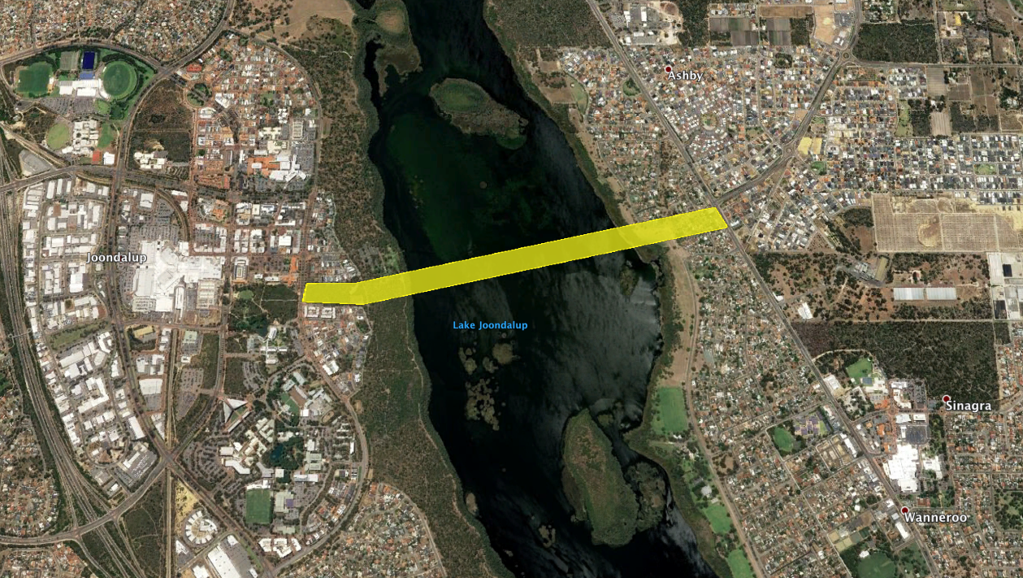

Figure 1: Proposed route of new traffic bridge linking Joondalup and Wanneroo.

Lake Joondalup is home to many different species, including several threatened species. In particular, the lake falls within the Northern Swan Coastal Plain Important Bird Area. The lake is home to the non-breeding range of Carnaby’s Black Cockatoo, an endangered species of cockatoo. The lake is also home to several species of threatened migratory shorebirds In recognition of the need for international action to maintain migratory bird populations, Australia has signed bilateral agreements with China, Japan and the Republic of Korea to protect shorebirds and their habitats, and all are signatories to the Convention for the Protection of Wetlands of International Importance (Ramsar Convention). A flyway represents the collective migration routes of waterbirds, including shorebirds, between their breeding and non-breeding areas. There are nine flyways globally: the East Asian - Australasian Flyway (EAAF) encompasses Australia, New Zealand and another 21 countries. Threatened migratory birds known to have used Lake Joondalup as a foraging site include: Great Knot, Curlew Sandpiper, Lesser Sand Plover, Grey-tailed Tattler, Eastern Curlew and Australasian Bittern. These birds rely upon areas of open mudflat upon which to forage.

**References**:

Brittain R.K., (1990), Yellagonga Regional Park – Ethnology Position Paper, Kidd and Povey Pty Ltd, Yokine, prepared for the Department of Planning and Urban Development, Perth, Western Australia.

Department of Conservation and Land Management, (2003). Yellagonga Park Regional Management Plan, Perth, Western Australia.

["Important Bird Areas factsheet: Northern Swan Coastal Plain"](http://www.birdlife.org/datazone/sitefactsheet.php?id=26933). [BirdLife International](https://en.wikipedia.org/wiki/BirdLife_International). Retrieved 14 May 2019

**Table 1:** Water chemistry data from Lake Joondalup over multiple sampling years.

|  |  |  |  |  |  |  |  |  |
| --- | --- | --- | --- | --- | --- | --- | --- | --- |
| **Year** | **Temperature (°C)** | **pH** | **Salinity (ms/cm)** | **Turbidity (NTUs)** | **Dissolved Oxygen (%)** | **Phosphates**  **(Ppm/mgL)** | **Petroleum (mg/L)** | **Nitrates (Ppm/mgL)** |
| **1999** | 21.1 | 8.5 | 2.8 | 5 | 102 | .05 | 1.2 | .05 |
| **2001** | 21.4 | 8.6 | 2.7 | 6 | 100 | .04 | 1.1 | .04 |
| **2004** | 24 | 8.4 | 2.9 | 5 | 103 | .05 | 1.3 | .04 |
| **2007** | 22.1 | 8.7 | 2.8 | 6 | 102 | .05 | 1.2 | .05 |
| **2010** | 22.6 | 6.5 | 3.1 | 12 | 89 | .07 | 2.9 | .07 |
| **2013** | 23.2 | 7.1 | 3.3 | 12 | 91 | .06 | 3.0 | .06 |
| **2016** | 23.9 | 7.4 | 3.4 | 13 | 92 | .07 | 2.9 | .08 |
| **2019** | 24.2 | 7.9 | 3.3 | 13 | 95 | .07 | 3.1 | .06 |

|  |  |  |  |  |  |  |  |  |  |  |
| --- | --- | --- | --- | --- | --- | --- | --- | --- | --- | --- |
| **Macroinvertebrate** | **Classification** | **Disturbance Tolerance Level** | **Species Abundance and Diversity Per Year** | | | | | | | |
| **1998** | **2001** | **2004** | **2007** | **2010** | **2013** | **2016** | **2019** |
| Stonefly Nymph | Plecoptera | Very sensitive | 75 | 70 | 56 | 50 | 0 | 0 | 10 | 11 |
| Mayfly Nymph | Ephemeroptera | Very sensitive | 28 | 30 | 23 | 18 | 0 | 0 | 0 | 8 |
| Damselfly Nymph | Odonata | Tolerant | 57 | 49 | 45 | 56 | 0 | 34 | 45 | 63 |
| Freshwater Shrimp | Decapoda | Very tolerant | 87 | 82 | 90 | 93 | 70 | 78 | 85 | 98 |
| Leech | Hirudinea | Very tolerant | 5 | 6 | 5 | 7 | 6 | 5 | 5 | 6 |
| Freshwater Snail | Gastropoda | Very tolerant | 23 | 29 | 23 | 25 | 12 | 15 | 18 | 20 |
| Water mite | Acarina | Sensitive | 13 | 15 | 16 | 17 | 0 | 0 | 0 | 2 |
| Water Boatman | Corixidae | Very tolerant | 49 | 45 | 56 | 60 | 103 | 95 | 86 | 79 |
| Dragonfly Nymph | Odonata | Tolerant | 31 | 35 | 34 | 42 | 0 | 4 | 18 | 14 |
| Caddisfly Larvae | Trichoptera | Very sensitive | 18 | 16 | 21 | 19 | 0 | 1 | 2 | 0 |
| Biting Midge Larvae | Ceratopogonidae | Tolerant | 42 | 48 | 52 | 36 | 0 | 0 | 0 | 0 |
| Freshwater Mussel | Bivalvia | Tolerant | 3 | 2 | 5 | 3 | 0 | 2 | 1 | 3 |
| Springtail | Collembola | Very tolerant | 17 | 23 | 12 | 16 | 34 | 31 | 37 | 45 |
| Flatworm | Turbellaria | Very tolerant | 13 | 16 | 14 | 10 | 12 | 13 | 10 | 16 |
| Ostracod | Ostracoda | Sensitive | 7 | 3 | 1 | 2 | 0 | 0 | 2 | 6 |
| Crane Fly Larvae | Tipulidae | Tolerant | 6 | 9 | 8 | 6 | 0 | 2 | 6 | 8 |

**Table 2:** Macroinvertebrate species diversity, abundance and pollution tolerance levels during sampling years.

|  |  |
| --- | --- |
| **Introduction** |  |
| **Aim/Purpose** | To report on.. |
| **Results**  Constructs a table with a;   * Title which incorporates the variables * Column and row headings * Accurate units. | **Title:** |
| **Graph**  Constructs a graph with   * A suitable title incorporating the variables * Axes labels * An incremental scale * Accurate plotting of data.   Always use a pencil and ruler! | Title:  Macintosh HD:Users:chantalsimpson:Desktop:3.tiff |
| **Discussion**  Summarise the results from your investigation  Describe the patterns and trends visible in your data. Did species go up or down over time? Why did they go up or down?  How will the proposed bridge affect the macroinvertebrate abundance and diversity? Why do you think they will be affected. Refer to your data to support your opinion.  What are the impacts of changes in macro invertebrate species diversity and abundance?  What other impacts might the proposed bridge have on the lake ecosystem? Use the background information to assist you in your answer.  Are there cultural aspects that need to be considered prior to the construction of the bridge?  What are the positives and negatives of the bridge being built? |  |
| **Reliability and Validity**  Were the results of this report reliable? How do you know?  Were the results of this report valid? How do you know? |  |
| **Mitigation**  If you were to approve the bridge, what rules would you put forward that the builder should follow?  What changes would you recommend to their plan before building?  What measures can be put in place to minimise the risk/harm to the Lake Joondalup ecosystem? |  |
| **Evaluation** *Write this in paragraph form using full sentences and answering the questions below.*  **1.** Describe at least two limitations to the information contained in this report.  **2.**What can be done to improve the value of the information you have based your decision on? |  |
| **Conclusion** *Write this using full sentences. Consider the following questions*  Based off the data you have analysed, would you support the construction of the bridge? Provide evidence from the data to justify your position. |  |

|  |  |  |  |
| --- | --- | --- | --- |
| **Section** | **Description** | **Marks Available** | **Marks Received** |
| **Introduction** | Provides background information about the location of the proposed project.  Provides background information about the proposed project. | 6  4 | /10 |
| **Results (Table and Notes)** | Records data using required number of tables Includes appropriate labels in each table Identifies potential outliers in the raw data and states possible reasons for their value.  Tables contain data to be graphed rather than copies of tables provided. | 2 2 2  2 | /8 |
| **Graph** | Completes all required graphs  Includes an appropriate title for each graph stating the variables being graphed.  Correctly labels all axes, including correct units.  Uses correct type of graph for each graph Correctly plots points on all graphs Pencil and Ruler for all graphs | 4 1  1 1 1 1 | /10 |
| **Discussion** | Describes patterns and trends in the data.  Compares data between sampling years. Describes potential impact of abiotic factors on macroinvertebrate species abundance and diversity.  Describe potential impacts to other aspects of Lake Joondalup (migratory birds, Indigenous culture, etc) Uses questions to form paragraphs rather than simple answers. Provides recommendations on how to minimise the impact of the bridge on species abundance and diversity. | 2  2  10  6  1  5 | /26 |
| **Reliability** | Comments on the reliability and validity of the data collected | 4 | /4 |
| **Mitigation** | Provides recommendations to the plan for the bridge before it proceeds.  Provides realistic strategies to minimise harm to the Lake Joondalup ecosystem. | 3  3 | /6 |
| **Evaluation** | Describes at least two limitations with the experiment that may affect the accuracy of the data Suggests at least two improvements for the experiment in the future | 2  2 | /4 |
| **Conclusion** | Summarises findings from the investigation Provides justification for the approval or rejection of the bridge. | 1 4 | /5 |
| **Total Marks** |  | 73 | /73 |